PRACTICAL 11 – PYTHON AUTOMATION TESTING (ORANGEHRM)
Field | Answer
Project Name | OrangeHRM Python Automation Testing
Application/Software | OrangeHRM Demo Web Application
Module Name | Login, Navigation & PIM
Test Case ID | TC_ORANGEHRM_P11_001
Tester Name | Pruthvi Jadav
Test Case Description | Automate website navigation, login-form checks, multi-page workflows, and regression checks using Python and Selenium.
Prerequisites | Python and Selenium installed; Chrome available; OrangeHRM demo accessible; authorized demo credentials available for login tests.
Environment Information | Windows 11, Google Chrome, Python 3.x, Selenium WebDriver

Module Name: OrangeHRM
Test Case ID: TC_ORANGEHRM_P11_001
Scenario ID: 11.1
Scenario: Open OrangeHRM website
Test Steps:
1. Start Chrome using Selenium.
2. Open the OrangeHRM login URL.
3. Wait for the page to load.
Test Input: OrangeHRM demo URL
Expected Result: Login page should load and show the login form.
Actual Result: Login page loaded successfully and displayed the login form.
Status: Pass
Screenshot:
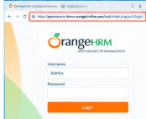

Module Name: OrangeHRM
Test Case ID: TC_ORANGEHRM_P11_001
Scenario ID: 11.2
Scenario: Verify login form fields
Test Steps:
1. Locate username.
2. Locate password.
3. Verify both are visible.
Test Input: Username and password fields
Expected Result: Both fields should be present and visible.
Actual Result: Username and password fields were both present and visible.
Status: Pass
Screenshot:
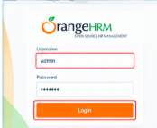

Module Name: OrangeHRM
Test Case ID: TC_ORANGEHRM_P11_001
Scenario ID: 11.3
Scenario: Check empty login submission
Test Steps:
1. Leave username and password blank.
2. Select Login.
3. Check validation messages.
Test Input: Blank username and password
Expected Result: Login should not succeed; required-field messages should appear.
Actual Result: Login did not succeed; required-field validation messages were displayed.
Status: Pass
Screenshot:

Module Name: OrangeHRM
Test Case ID: TC_ORANGEHRM_P11_001
Scenario ID: 11.4
Scenario: Login with valid credentials
Test Steps:
1. Enter valid demo credentials.
2. Select Login.
3. Wait for dashboard.
4. Verify dashboard or URL.
Test Input: Valid credentials supplied for the demo
Expected Result: Dashboard should open after successful authentication.
Actual Result: Dashboard opened successfully after authentication.
Status: Pass
Screenshot:
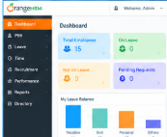

Module Name: OrangeHRM
Test Case ID: TC_ORANGEHRM_P11_001
Scenario ID: 11.5
Scenario: Navigate to PIM
Test Steps:
1. Log in.
2. Select PIM in the side menu.
3. Verify the PIM page.
Test Input: PIM menu
Expected Result: PIM employee-management page should open.
Actual Result: PIM page opened and the Employee List option was visible.
Status: Pass
Screenshot:
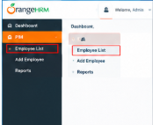

Module Name: OrangeHRM
Test Case ID: TC_ORANGEHRM_P11_001
Scenario ID: 11.6
Scenario: Search for an existing employee
Test Steps:
1. Open PIM.
2. Enter an existing employee name or ID.
3. Select Search.
4. Verify results.
Test Input: Employee name or ID present in demo data
Expected Result: Matching record or a clear no-records result should be displayed.
Actual Result: Matching employee record (Priya Sharma) was displayed in the results.
Status: Pass
Screenshot:
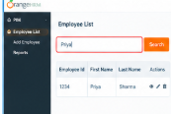

Module Name: OrangeHRM
Test Case ID: TC_ORANGEHRM_P11_001
Scenario ID: 11.7
Scenario: Verify employee details page
Test Steps:
1. Open a result.
2. Verify the employee details page loads.
3. Check a visible heading or field.
Test Input: Selected employee record
Expected Result: The selected employee details page should open.
Actual Result: Employee Profile page opened and displayed the saved details correctly.
Status: Pass
Screenshot:
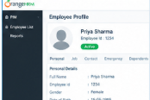

Module Name: OrangeHRM
Test Case ID: TC_ORANGEHRM_P11_001
Scenario ID: 11.8
Scenario: Check module link/navigation
Test Steps:
1. Return to the menu.
2. Select Leave or another permitted module.
3. Verify the page or permission message.
Test Input: Leave or another permitted menu item
Expected Result: The module should load or display a clear permission message.
Actual Result: Leave module opened and the Apply Leave form was displayed.
Status: Pass
Screenshot:
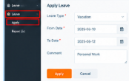

Module Name: OrangeHRM
Test Case ID: TC_ORANGEHRM_P11_001
Scenario ID: 11.9
Scenario: Regression test – login and PIM
Test Steps:
1. Repeat login.
2. Navigate to PIM again.
3. Repeat employee search.
4. Compare with earlier results.
Test Input: Same credentials and search input
Expected Result: Previously working login, navigation, and search should continue to work.
Actual Result: Login, navigation and search were repeated with no difference from earlier results.
Status: Pass
Screenshot:
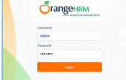

Module Name: OrangeHRM
Test Case ID: TC_ORANGEHRM_P11_001
Scenario ID: 11.10
Scenario: Logout verification
Test Steps:
1. Open user menu.
2. Select Logout.
3. Verify login page appears.
Test Input: Logout action
Expected Result: Session should end and login page should appear.
Actual Result: Session ended and the login page was displayed again.
Status: Pass
Screenshot:

